<https://clickhouse.com/docs>

<https://github.com/ClickHouse/examples>

# ClickHouse

ClickHouse® is a high-performance, column-oriented SQL database management system (DBMS) for online analytical processing (OLAP).

# Data Replication and Integrity

ClickHouse uses an asynchronous multi-master replication scheme to ensure that data is stored redundantly on multiple nodes. After being written to any available replica, all the remaining replicas retrieve their copy in the background. The system maintains identical data on different replicas. Recovery after most failures is performed automatically, or semi-automatically in complex cases.

# Best Practices for Inserts

By default, each insert sent to ClickHouse causes ClickHouse to immediately create a part of storage containing the data from the insert together with other metadata that needs to be stored. Therefore, sending a smaller amount of inserts that each contain more data, compared to sending a larger amount of inserts that each contain less data, will reduce the number of writes required. Generally, we recommend inserting data in fairly large batches of at least 1,000 rows at a time, and ideally between 10,000 to 100,000 rows. (Further details [here](https://clickhouse.com/blog/asynchronous-data-inserts-in-clickhouse#data-needs-to-be-batched-for-optimal-performance)).

By default, inserts into ClickHouse are synchronous and idempotent (i.e. performing the same insert operation multiple times has the same effect as performing it once). For tables of the MergeTree engine family, ClickHouse will, by default, automatically [deduplicate inserts](https://clickhouse.com/blog/common-getting-started-issues-with-clickhouse#5-deduplication-at-insert-time).

We recommend inserting directly into a MergeTree (or Replicated table), balancing the requests across a set of nodes if the data is sharded, and setting internal_replication=true. This will leave ClickHouse to replicate the data to any available replica shards and ensure the data is eventually consistent.

If this client side load balancing is inconvenient then users can insert via a [distributed table](https://clickhouse.com/docs/en/engines/table-engines/special/distributed) which will then distribute writes across the nodes. Again, it is advised to set internal_replication=true. It should be noted however that this approach is a little less performant as writes have to be made locally on the node with the distributed table and then sent to the shards.

There are scenarios where client-side batching is not feasible e.g. an observability use case with 100s or 1000s of single-purpose agents sending logs, metrics, traces, etc. In this scenario real-time transport of that data is key to detect issues and anomalies as quickly as possible. Furthermore, there is a risk of event spikes in the observed systems, which could potentially cause large memory spikes and related issues when trying to buffer observability data client-side. If large batches cannot be inserted, users can delegate batching to ClickHouse using [asynchronous inserts](https://clickhouse.com/docs/en/cloud/bestpractices/asynchronous-inserts).

With asynchronous inserts, data is inserted into a buffer first and then written to the database storage later in 3 steps, as illustrated by the diagram below:

With asynchronous inserts enabled, ClickHouse:

(1) receives an insert query asynchronously.  
(2) writes the query's data into an in-memory buffer first.  
(3) sorts and writes the data as a part to the database storage, only when the next buffer flush takes place.

Before the buffer gets flushed, the data of other asynchronous insert queries from the same or other clients can be collected in the buffer. The part created from the buffer flush will potentially contain the data from several asynchronous insert queries. Generally, these mechanics shift the batching of data from the client side to the server side (ClickHouse instance).

# Table parts

The data from each table in the ClickHouse [MergeTree engine family](https://clickhouse.com/docs/en/engines/table-engines/mergetree-family) is organized on disk as a collection of immutable data parts.

A data part is created whenever a set of rows is inserted into the table. The following diagram sketches this:

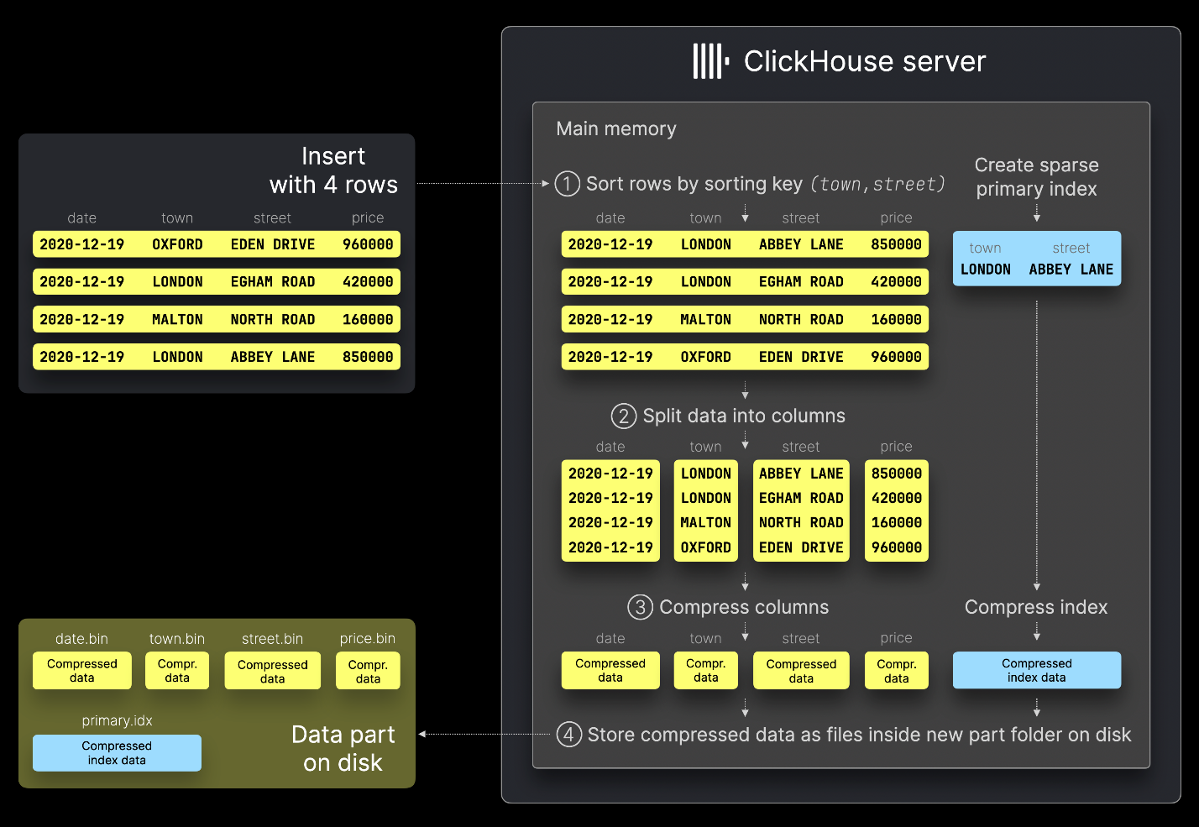

## Part merges

To manage the number of parts per table, a [background merge](https://clickhouse.com/docs/en/merges) job periodically combines smaller parts into larger ones until they reach a [configurable](https://clickhouse.com/docs/en/operations/settings/merge-tree-settings#max-bytes-to-merge-at-max-space-in-pool) compressed size (typically ~150 GB). Merged parts are marked as inactive and deleted after a [configurable](https://clickhouse.com/docs/en/operations/settings/merge-tree-settings#old-parts-lifetime) time interval. Over time, this process creates a hierarchical structure of merged parts, which is why it’s called a MergeTree table:

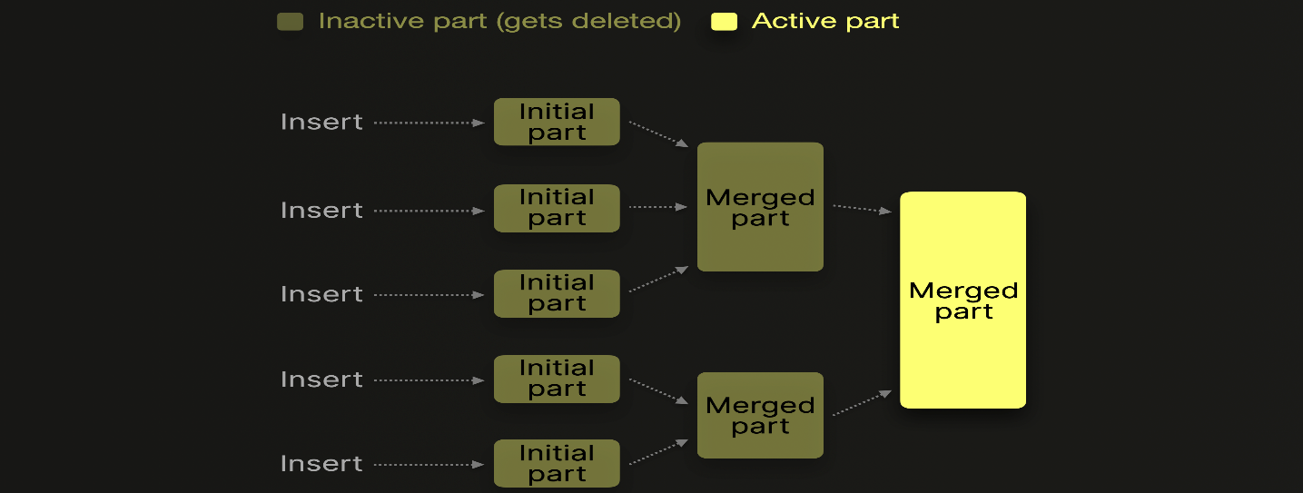

The merge level of a part is incremented by one with each additional merge. A level of 0 means the part is new and has not been merged yet. Parts that were merged into larger parts are marked as [inactive](https://clickhouse.com/docs/en/operations/system-tables/parts) and finally deleted after a [configurable](https://clickhouse.com/docs/en/operations/settings/merge-tree-settings#old-parts-lifetime) time (8 minutes by default). Over time, this creates a **tree** of merged parts. Hence the name [merge tree](https://clickhouse.com/docs/en/engines/table-engines/mergetree-family) table.

ClickHouse does not necessarily load all parts to be merged into memory at once, as sketched in the [previous example](https://clickhouse.com/docs/en/merges#concurrent-merges). Based on several [factors](https://github.com/ClickHouse/clickhouse-private/blob/68008d83e6c3e8487bbbb7d672d35082f80f9453/src/Storages/MergeTree/MergeTreeSettings.cpp#L208), and to reduce memory consumption (sacrificing merge speed), so-called [vertical merging](https://github.com/ClickHouse/clickhouse-private/blob/68008d83e6c3e8487bbbb7d672d35082f80f9453/src/Storages/MergeTree/MergeTreeSettings.cpp#L207) loads and merges parts by chunks of blocks instead of in one go.

# Table partitions

Partitions group the [data parts](https://clickhouse.com/docs/en/parts) of a table in the [MergeTree engine family](https://clickhouse.com/docs/en/engines/table-engines/mergetree-family) into organized, logical units, which is a way of organizing data that is conceptually meaningful and aligned with specific criteria, such as time ranges, categories, or other key attributes. These logical units make data easier to manage, query, and optimize.

Whenever a set of rows is inserted into the table, instead of creating (at [least](https://clickhouse.com/docs/en/operations/settings/settings#max_insert_block_size)) one single data part containing all the inserted rows (as described [here](https://clickhouse.com/docs/en/parts)), ClickHouse creates one new data part for each unique partition key value among the inserted rows. With partitioning enabled, ClickHouse only [merges](https://clickhouse.com/docs/en/merges) data parts within, but not across partitions.

Be aware that querying across all partitions is typically slower than running the same query on a non-partitioned table.

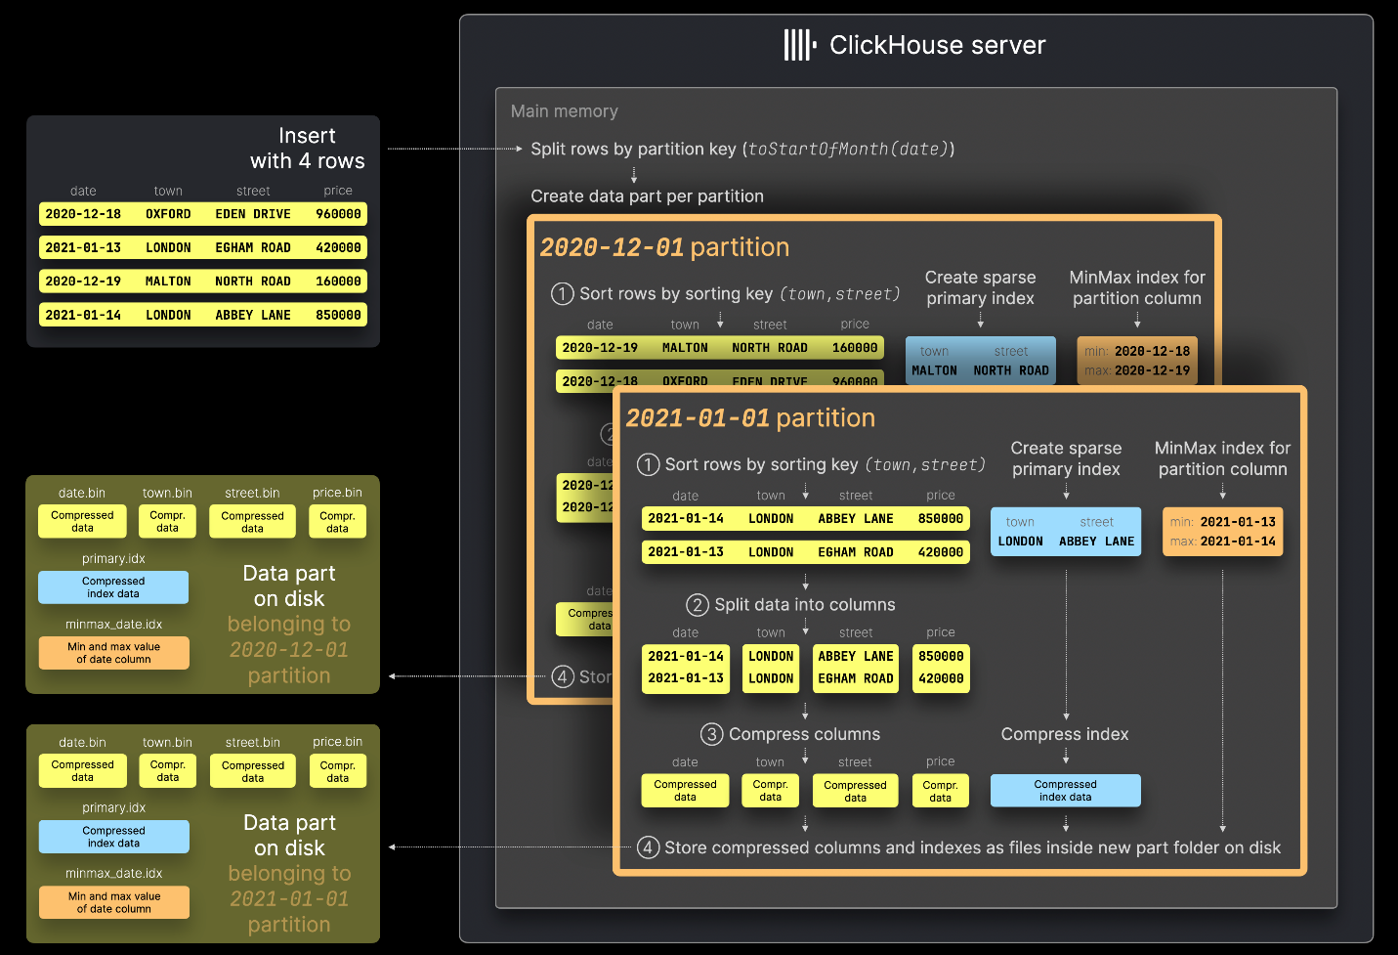

# ClickHouse Index Design

In traditional relational database management systems, the primary index would contain one entry per table row. This would result in the primary index containing 8.87 million entries for our data set. Such an index allows the fast location of specific rows, resulting in high efficiency for lookup queries and point updates. Searching an entry in a B(+)-Tree data structure has an average time complexity of O(log n).

Data is quickly written to a table [part by part](https://clickhouse.com/docs/en/engines/table-engines/mergetree-family/mergetree#mergetree-data-storage), with rules applied for merging the parts in the background. In ClickHouse each part has its own primary index. When parts are merged, then the merged part’s primary indexes are also merged. At the very large scale that ClickHouse is designed for, it is paramount to be very disk and memory efficient. Therefore, instead of indexing every row, the primary index for a part has one index entry (known as a ‘mark’) per group of rows (called ‘granule’) - this technique is called **sparse index**.

Sparse indexing is possible because ClickHouse is storing the rows for a part on disk ordered by the primary key column(s). Instead of directly locating single rows (like a B-Tree based index), the sparse primary index allows it to quickly (via a binary search over index entries) identify groups of rows that could possibly match the query. The located groups of potentially matching rows (granules) are then in parallel streamed into the ClickHouse engine in order to find the matches. This index design allows for the primary index to be small (it can, and must, completely fit into the main memory), whilst still significantly speeding up query execution times: especially for range queries that are typical in data analytics use cases.

# Primary Key

If we would have specified only the sorting key, then the primary key would be implicitly defined to be equal to the sorting key.

In order to be memory efficient we explicitly specified a primary key that only contains columns that our queries are filtering on. The primary index that is based on the primary key is completely loaded into the main memory.

In order to have consistency in the guide’s diagrams and in order to maximize compression ratio we defined a separate sorting key that includes all of our table's columns (if in a column similar data is placed close to each other, for example via sorting, then that data will be compressed better).

### Data granules

For data processing purposes, a table's column values are logically divided into granules. A granule is the smallest indivisible data set that is streamed into ClickHouse for data processing. This means that instead of reading individual rows, ClickHouse is always reading (in a streaming fashion and in parallel) a whole group (granule) of rows.

the primary index stores the primary key column values from each 8192nd row of the table. The primary key entries are called index marks because each index entry is marking the start of a specific data range. The primary index is used for selecting granules.

The primary index file is completely loaded into the main memory. If the file is larger than the available free memory space then ClickHouse will raise an error.

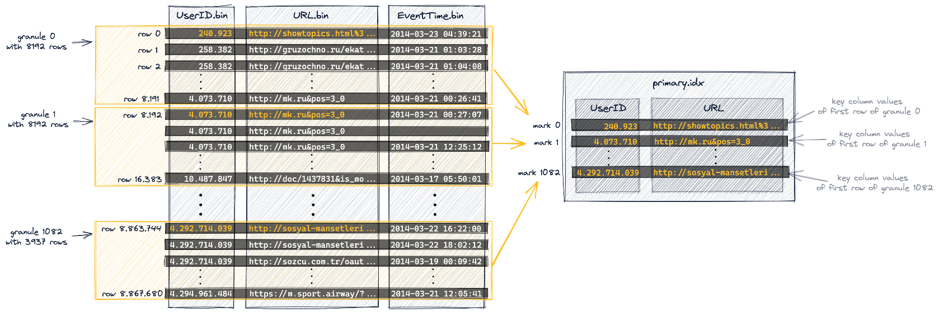

In ClickHouse the physical locations of all granules for our table are stored in mark files. Similar to data files, there is one mark file per table column. Once ClickHouse has identified and selected the index mark for a granule that can possibly contain matching rows for a query, a positional array lookup can be performed in the mark files in order to obtain the physical locations of the granule.

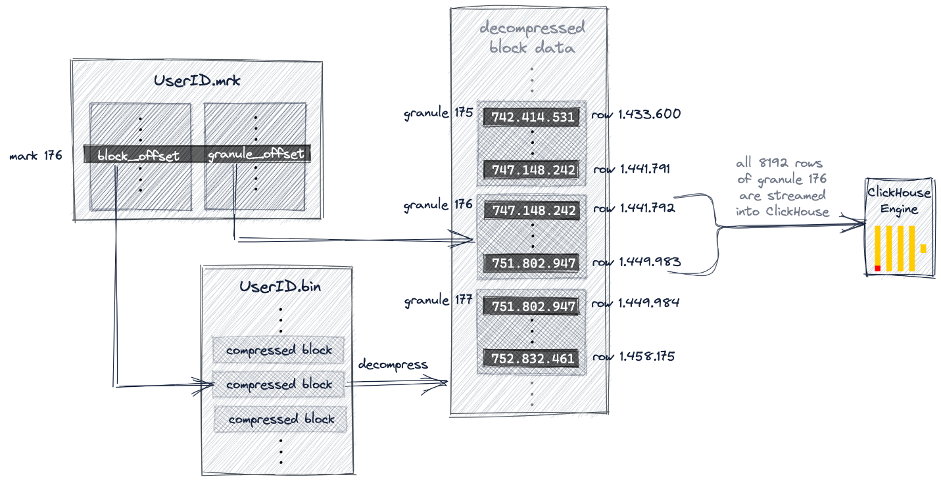

# Primary Key vs Order By

Primary key and order by are the same except order by columns that aren’t in primary key columns determines the data sortation in granule level.

# Generic exclusion search algorithm

When a query is filtering on a column that is part of a compound key and is the first key column, [then ClickHouse is running the binary search algorithm over the key column's index marks](https://clickhouse.com/docs/en/guides/best-practices/sparse-primary-indexes#the-primary-index-is-used-for-selecting-granules). But when the it is the second column clickhouse uses generic exclusion search algorithm. **The effectiveness of that algorithm is dependant on the cardinality difference** between the second column and its predecessor first key column.

Example:

*SELECT* UserID, count(UserID) *AS* Count  
*FROM* hits_UserID_URL  
*WHERE* URL = 'http://public_search'  
*GROUP* *BY* UserID  
*ORDER* *BY* Count *DESC*  
*LIMIT* 10;

If the first column has low cardinality:

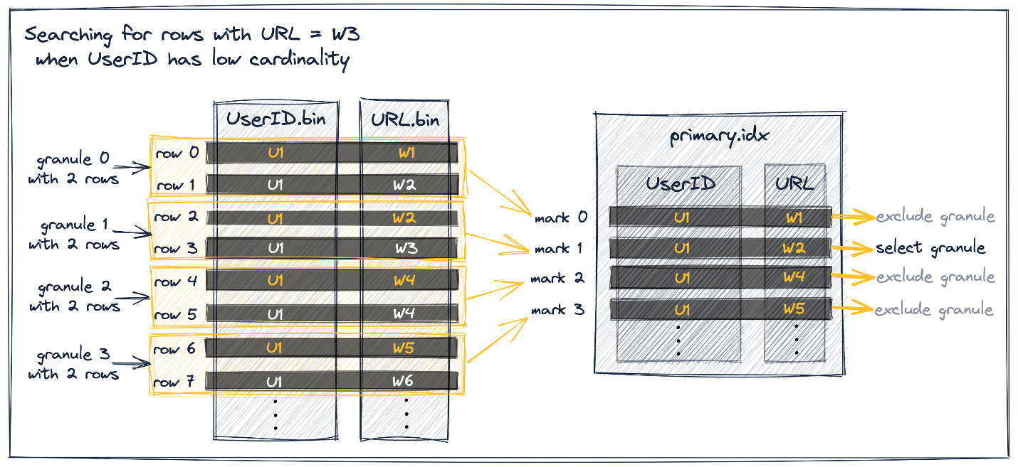

If the first column has high cardinality:

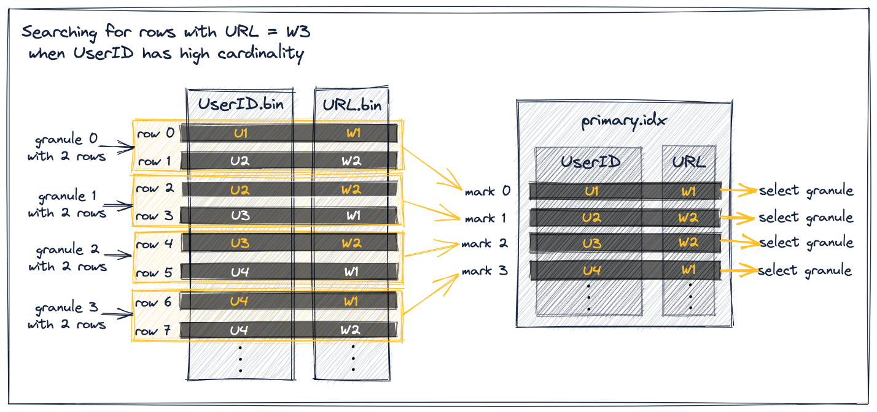

Because of the similarly high cardinality of the primary key columns UserID and URL, a query that filters on the second key column [doesn’t benefit much from the second key column being in the index](https://clickhouse.com/docs/en/guides/best-practices/sparse-primary-indexes#generic-exclusion-search-slow).

Therefore it makes sense to remove the second key column from the primary index (resulting in less memory consumption of the index) and to [use multiple primary indexes](https://clickhouse.com/docs/en/guides/best-practices/sparse-primary-indexes#multiple-primary-indexes) instead.

And to solve this problem we can make a projection.

# Ordering key columns efficiently

In a compound primary key the order of the key columns can significantly influence both:

* the efficiency of the filtering on secondary key columns in queries, and
* the compression ratio for the table's data files.

When a query is filtering on at least one column that is part of a compound key, and is the first key column, [then ClickHouse is running the binary search algorithm over the key column's index marks](https://clickhouse.com/docs/en/guides/best-practices/sparse-primary-indexes#the-primary-index-is-used-for-selecting-granules).

When a query is filtering (only) on a column that is part of a compound key, but is not the first key column, [then ClickHouse is using the generic exclusion search algorithm over the key column's index marks](https://clickhouse.com/docs/en/guides/best-practices/sparse-primary-indexes#secondary-key-columns-can-not-be-inefficient).

For the second case the ordering of the key columns in the compound primary key is significant for the effectiveness of the [generic exclusion search algorithm](https://github.com/ClickHouse/ClickHouse/blob/22.3/src/Storages/MergeTree/MergeTreeDataSelectExecutor.cpp#L1444).

Query execution is significantly more effective and faster on the table where we ordered the key columns by cardinality in ascending order.

The compression ratio is significantly higher for the table where we ordered the key columns by cardinality in ascending order.

Having a good compression ratio for the data of a table's column on disk not only saves space on disk, but also makes queries (especially analytical ones) that require the reading of data from that column faster, as less i/o is required for moving the column's data from disk to the main memory (the operating system's file cache).

Example of primary key in advanced:

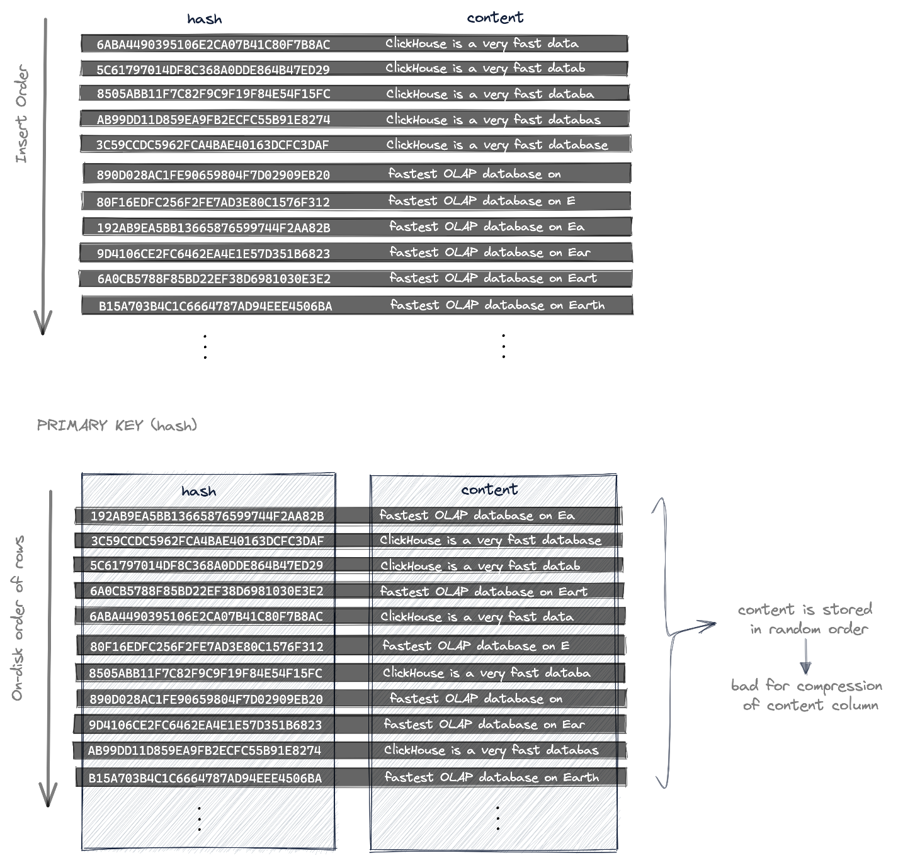

* specific rows can be retrieved [very quickly](https://clickhouse.com/docs/en/guides/best-practices/sparse-primary-indexes#the-primary-index-is-used-for-selecting-granules), but
* the table's rows (their column data) are stored on disk ordered ascending by (the unique and random) hash values. Therefore also the content column's values are stored in random order with no data locality resulting in a **suboptimal compression ratio for the content column data file**.

In order to significantly improve the compression ratio for the content column while still achieving fast retrieval of specific rows, pastila.nl is using two hashes (and a compound primary key) for identifying a specific row:

* a hash of the content, as discussed above, that is distinct for distinct data, and
* a [locality-sensitive hash (fingerprint)](https://en.wikipedia.org/wiki/Locality-sensitive_hashing) that does **not** change on small changes of data.

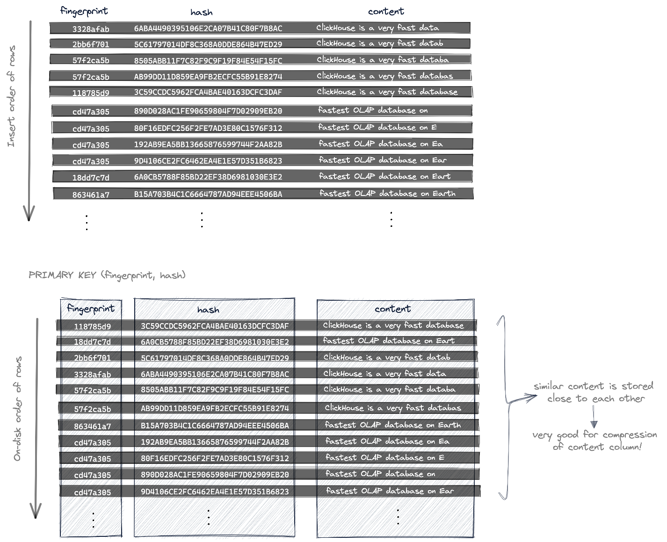

# Data Skipping Indexes

No matter how carefully tuned the primary key, there will inevitably be query use cases that can not efficiently use it.

In a traditional relational database, one approach to this problem is to attach one or more "secondary" indexes to a table. This is a b-tree structure that permits the database to find all matching rows on disk in O(log(n)) time instead of O(n) time (a table scan), where n is the number of rows. However, this type of secondary index will not work for ClickHouse (or other column-oriented databases) because there are no individual rows on the disk to add to the index. Instead, ClickHouse provides a different type of index, which in specific circumstances can significantly improve query speed.

ALTER TABLE table_2 ADD INDEX idx_table_2_col_3 column_3 TYPE set(100) GRANULARITY 2;

Normally skip indexes are only applied on newly inserted data, so just adding the index won't affect the above query. instead:

ALTER TABLE table_2 MATERIALIZE INDEX idx_table_2_col_3;

GRANULARITY. Each indexed block consists of GRANULARITY granules. For example, if the granularity of the primary table index is 8192 rows, and the index granularity is 4, each indexed "block" will be 32768 rows.

## Skip Index Types

### minmax

This lightweight index type requires no parameters. It stores the minimum and maximum values of the index expression for each block (if the expression is a tuple, it separately stores the values for each member of the element of the tuple). This type is ideal for columns that tend to be loosely sorted by value. This index type is usually the least expensive to apply during query processing.

### set

This lightweight index type accepts a single parameter of the max_size of the value set per block (0 permits an unlimited number of discrete values). This set contains all values in the block (or is empty if the number of values exceeds the max_size). This index type works well with columns with low cardinality within each set of granules (essentially, "clumped together") but higher cardinality overall.

The cost, performance, and effectiveness of this index is dependent on the cardinality within blocks. If each block contains a large number of unique values, either evaluating the query condition against a large index set will be very expensive, or the index will not be applied because the index is empty due to exceeding max_size.

### Bloom Filter Types

A Bloom filter is a data structure that allows space-efficient testing of set membership at the cost of a slight chance of false positives. A false positive is not a significant concern in the case of skip indexes because the only disadvantage is reading a few unnecessary blocks. However, the potential for false positives does mean that the indexed expression should be expected to be true, otherwise valid data may be skipped.

Because Bloom filters can more efficiently handle testing for a large number of discrete values, they can be appropriate for conditional expressions that produce more values to test. In particular, a Bloom filter index can be applied to arrays, where every value of the array is tested, and to maps, by converting either the keys or values to an array using the mapKeys or mapValues function.

There are three Data Skipping Index types based on Bloom filters:

* The basic **bloom_filter** which takes a single optional parameter of the allowed "false positive" rate between 0 and 1 (if unspecified, .025 is used).
* The specialized **tokenbf_v1**. It takes three parameters, all related to tuning the bloom filter used: (1) the size of the filter in bytes (larger filters have fewer false positives, at some cost in storage), (2) number of hash functions applied (again, more hash filters reduce false positives), and (3) the seed for the bloom filter hash functions. See the calculator [here](https://hur.st/bloomfilter/) for more detail on how these parameters affect bloom filter functionality. This index works only with String, FixedString, and Map datatypes. The input expression is split into character sequences separated by non-alphanumeric characters. For example, a column value of This is a candidate for a "full text" search will contain the tokens This is a candidate for full text search. It is intended for use in LIKE, EQUALS, IN, hasToken() and similar searches for words and other values within longer strings. For example, one possible use might be searching for a small number of class names or line numbers in a column of free form application log lines.
* The specialized **ngrambf_v1**. This index functions the same as the token index. It takes one additional parameter before the Bloom filter settings, the size of the ngrams to index. An ngram is a character string of length n of any characters, so the string A short string with an ngram size of 4 would be indexed as:

'A sh', ' sho', 'shor', 'hort', 'ort ', 'rt s', 't st', ' str', 'stri', 'trin', 'ring'

This index can also be useful for text searches, particularly languages without word breaks, such as Chinese.

<https://clickhouse.com/docs/en/engines/table-engines/mergetree-family/mergetree#functions-support>

# Projection Table

*ALTER* *TABLE* hits_UserID_URL  
 *ADD* PROJECTION prj_url_userid  
 (  
 *SELECT* *  
 *ORDER* *BY* (URL, UserID)  
 );

*ALTER* *TABLE* hits_UserID_URL  
 MATERIALIZE PROJECTION prj_url_userid;

the projection is creating a **hidden table** whose row order and primary index is based on the given ORDER BY clause of the projection.

the hidden table is not listed by the SHOW TABLES query.

we use the MATERIALIZE keyword in order to immediately populate the hidden table with all 8.87 million rows from the source table [hits_UserID_URL](https://clickhouse.com/docs/en/guides/best-practices/sparse-primary-indexes#a-table-with-a-primary-key).

if new rows are inserted into the source table hits_UserID_URL, then that rows are automatically also inserted into the hidden table.

a query is always (syntactically) targeting the source table hits_UserID_URL, but if the row order and primary index of the hidden table allows a more effective query execution, then that hidden table will be used instead.

**please note that projections do not make queries that use ORDER BY more efficient, even if the ORDER BY matches the projection's ORDER BY statement.**

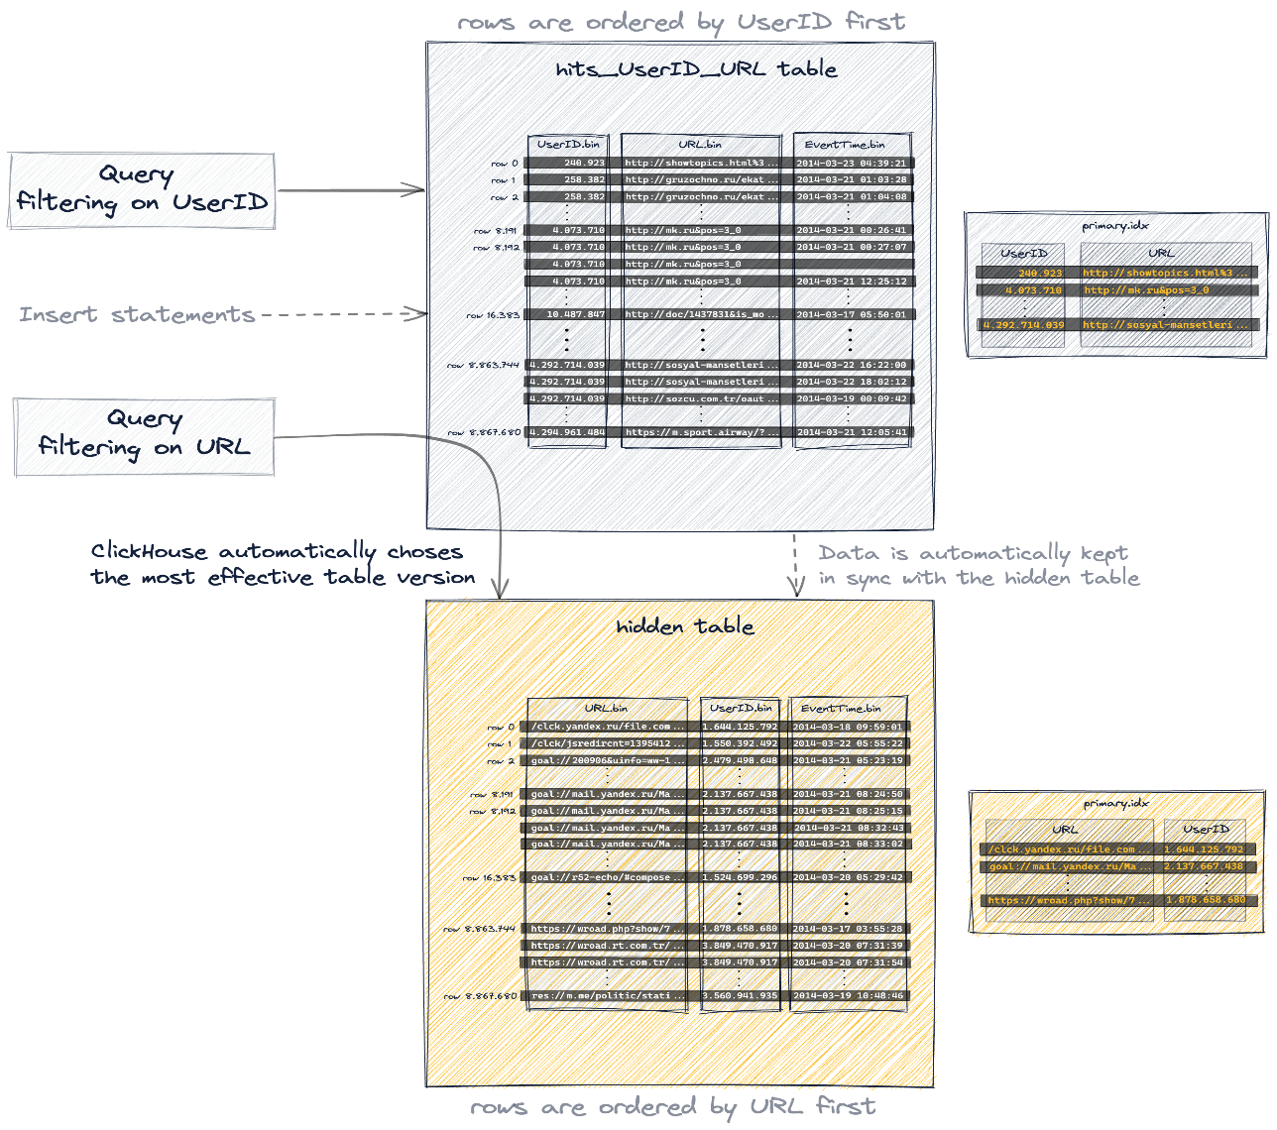

# Dictionary

A dictionary in ClickHouse provides an in-memory [key-value](https://en.wikipedia.org/wiki/Key%E2%80%93value_database) representation of data from various [internal and external sources](https://clickhouse.com/docs/en/sql-reference/dictionaries#dictionary-sources), optimizing for super-low latency lookup queries.

Dictionaries are useful for:

* Improving the performance of queries, especially when used with JOINs
* Enriching ingested data on the fly without slowing down the ingestion process

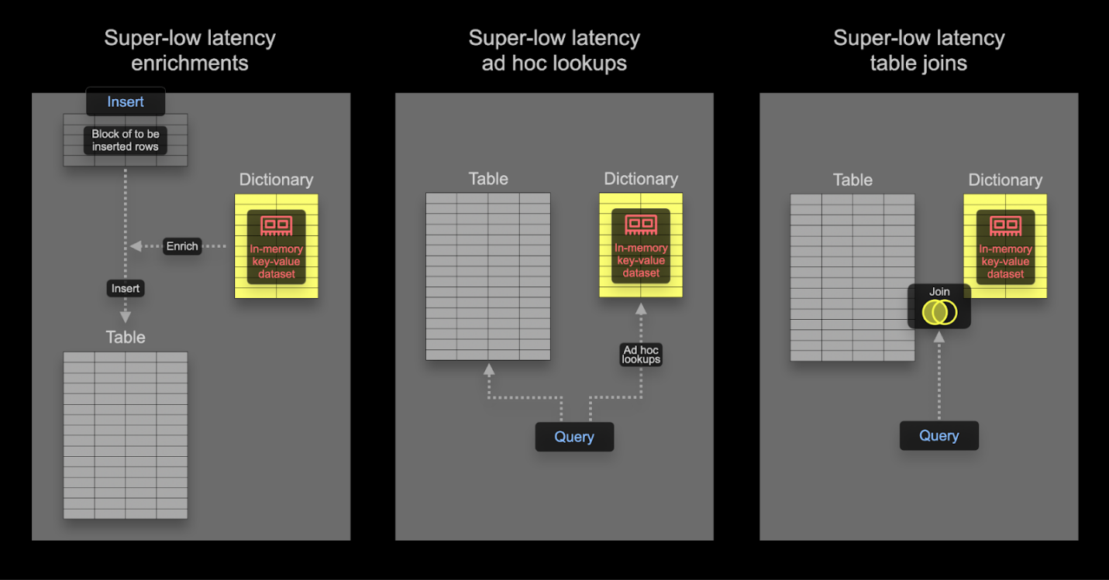

Data will be stored uncompressed in our dictionary, so we need some of memory if we were to store all columns (we won’t) in a dictionary. The dictionary will be replicated across our cluster, so this amount of memory needs to be reserved per node.

Our dictionary requires a primary key on which lookups will be performed. This is conceptually identical to a transactional database primary key and should be unique.

Example:

*CREATE* DICTIONARY votes_dict  
(  
 `PostId` UInt64,  
 `UpVotes` UInt32,  
 `DownVotes` UInt32  
)  
*PRIMARY* *KEY* PostId  
SOURCE(CLICKHOUSE(QUERY 'SELECT PostId, countIf(VoteTypeId = 2) AS UpVotes, countIf(VoteTypeId = 3) AS DownVotes FROM votes GROUP BY PostId'))  
LIFETIME(MIN 600 MAX 900)  
LAYOUT(HASHED())

In self-managed OSS, the above command needs to be executed on all nodes. We have specified a LIFETIME for the dictionary of MIN 600 MAX 900. LIFETIME is the update interval for the dictionary, with the values here causing a periodic reload at a random interval between 600 and 900s. This random interval is necessary in order to distribute the load on the dictionary source when updating on a large number of servers. During updates, the old version of a dictionary can still be queried, with only the initial load blocking queries. Note that setting (LIFETIME(0)) prevents dictionaries from updating. Dictionaries can be forcibly reloaded using the SYSTEM RELOAD DICTIONARY command.

*WITH* PostIds *AS*  
(  
 *SELECT* Id  
 *FROM* posts  
 *WHERE* Title ILIKE '%SQL%'  
)  
*SELECT* Id, Title,  
 dictGet('votes_dict', 'UpVotes', Id) *AS* UpVotes,  
 dictGet('votes_dict', 'DownVotes', Id) *AS* DownVotes,  
 abs(UpVotes - DownVotes) *AS* Controversial_ratio  
*FROM* posts  
*WHERE* (Id IN (PostIds)) AND (UpVotes > 10) AND (UpVotes > 10)  
*ORDER* *BY* Controversial_ratio *ASC*  
*LIMIT* 3

# Materialized View

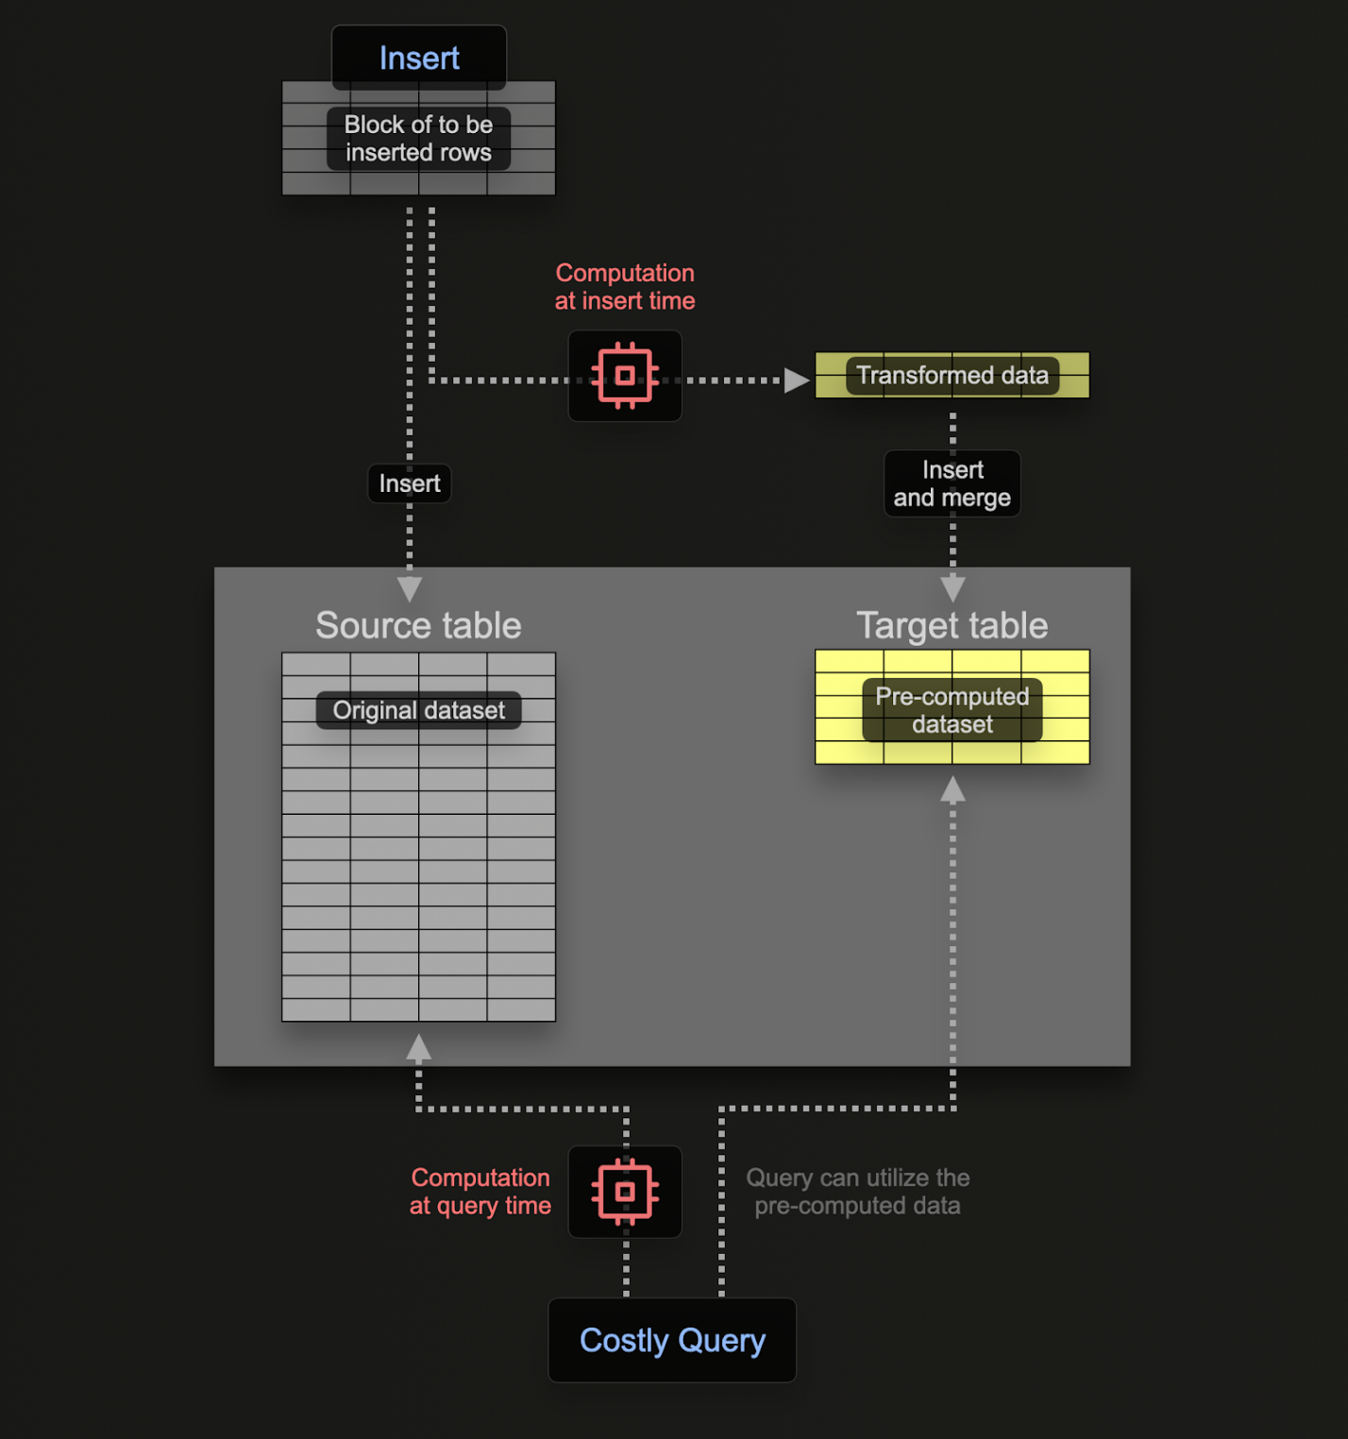

Example:

CREATE TABLE up_down_votes_per_day  
(  
 `Day` Date,  
 `UpVotes` UInt32,  
 `DownVotes` UInt32  
)  
ENGINE = SummingMergeTree  
ORDER BY Day

*CREATE* MATERIALIZED *VIEW* up_down_votes_per_day_mv *TO* up_down_votes_per_day *AS*  
*SELECT* toStartOfDay(CreationDate)::*Date* *AS* *Day*,  
 countIf(VoteTypeId = 2) *AS* UpVotes,  
 countIf(VoteTypeId = 3) *AS* DownVotes  
*FROM* votes  
*GROUP* *BY* *Day*

Materialized views allow users to shift the cost of computation from query time to insert time, resulting in faster SELECT queries.

Unlike in transactional databases like Postgres, a ClickHouse materialized view is just a trigger that runs a query on blocks of data as they are inserted into a table. The result of this query is inserted into a second "target" table. Should more rows be inserted, results will again be sent to the target table where the intermediate results will be updated and merged. This merged result is the equivalent of running the query over all of the original data.

The principal motivation for materialized views is that the results inserted into the target table represent the results of an aggregation, filtering, or transformation on rows. These results will often be a smaller representation of the original data (a partial sketch in the case of aggregations). This, along with the resulting query for reading the results from the target table being simple, ensures query times are faster than if the same computation was performed on the original data, shifting computation (and thus query latency) from query time to insert time.

Materialized views in ClickHouse are updated in real time as data flows into the table they are based on, functioning more like continually updating indexes. This is in contrast to other databases where materialized views are typically static snapshots of a query that must be refreshed (similar to ClickHouse [refreshable materialized views](https://clickhouse.com/docs/en/sql-reference/statements/create/view#refreshable-materialized-view)).

# Refreshable Materialized View

[**Refreshable materialized views**](https://clickhouse.com/docs/en/sql-reference/statements/create/view#refreshable-materialized-view) **are conceptually similar to materialized views in traditional OLTP databases, storing the result of a specified query for quick retrieval and reducing the need to repeatedly execute resource-intensive queries. Unlike ClickHouse’s** [**incremental materialized views**](https://clickhouse.com/docs/en/materialized-view)**, this requires the periodic execution of the query over the full dataset - the results of which are stored in a target table for querying. This result set should, in theory, be smaller than the original dataset, allowing the subsequent query to execute faster.**

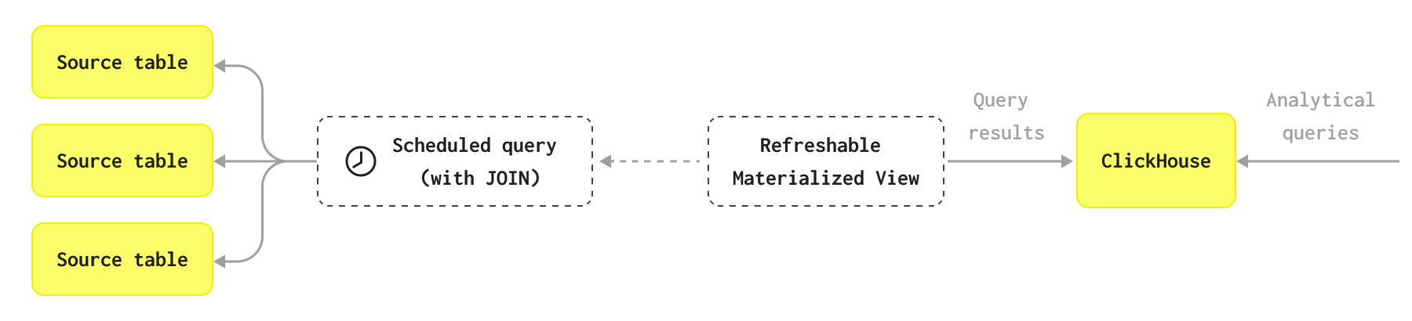

ClickHouse incremental materialized views are enormously powerful and typically scale much better than the approach used by refreshable materialized views, especially in cases where an aggregate over a single table needs to be performed. By only computing the aggregation over each block of data as it is inserted and merging the incremental states in the final table, the query only ever executes on a subset of the data. This method scales to potentially petabytes of data and is usually the preferred method.

However, there are use cases where this incremental process is not required or is not applicable. Some problems are either incompatible with an incremental approach or don't require real-time updates, with a periodic rebuild being more appropriate. For example, you may want to regularly perform a complete re-computation of a view over the full dataset because it uses a complex join, which is incompatible with an incremental approach.

Example:

*CREATE* MATERIALIZED *VIEW* imdb.actor_summary_mv  
REFRESH EVERY 1 *MINUTE* *TO* imdb.actor_summary *AS*  
*SELECT*  
 id,  
 *any*(actor_name) *AS* name,  
 uniqExact(movie_id) *AS* num_movies,  
 avg(rank) *AS* avg_rank,  
 uniqExact(genre) *AS* unique_genres,  
 uniqExact(director_name) *AS* uniq_directors,  
 max(created_at) *AS* updated_at  
*FROM*  
(  
 *SELECT*  
 imdb.actors.id *AS* id,  
 concat(imdb.actors.first_name, ' ', imdb.actors.last_name) *AS* actor_name,  
 imdb.movies.id *AS* movie_id,  
 imdb.movies.rank *AS* rank,  
 genre,  
 concat(imdb.directors.first_name, ' ', imdb.directors.last_name) *AS* director_name,  
 created_at  
 *FROM* imdb.actors  
 *INNER* *JOIN* imdb.roles *ON* imdb.roles.actor_id = imdb.actors.id  
 *LEFT* *JOIN* imdb.movies *ON* imdb.movies.id = imdb.roles.movie_id  
 *LEFT* *JOIN* imdb.genres *ON* imdb.genres.movie_id = imdb.movies.id  
 *LEFT* *JOIN* imdb.movie_directors *ON* imdb.movie_directors.movie_id = imdb.movies.id  
 *LEFT* *JOIN* imdb.directors *ON* imdb.directors.id = imdb.movie_directors.director_id  
)  
*GROUP* *BY* id  
*ORDER* *BY* num_movies *DESC*;

# Filling gaps in time-series data

When working with time-series data, there can be gaps in the data due to missing data or inactivity. Typically, we don't want those gaps to exist when we query the data. In this case, the WITH FILL clause can come in handy. This guide discusses how to use WITH FILL to fill gaps in your time-series data.

*SELECT*  
 toStartOfInterval(*timestamp*, toIntervalMillisecond(100)) *AS* bucket,  
 count() *AS* count,  
 sum(count) *OVER* (*ORDER* *BY* bucket) *AS* cumulative,  
 bar(cumulative, 0, 10, 10) *AS* barChart  
*FROM* MidJourney.images  
*WHERE* (*timestamp* >= {*start*:String}) AND (*timestamp* <= {*end*:String})  
*GROUP* *BY* *ALL*  
*ORDER* *BY* bucket *ASC*  
*WITH* FILL  
*FROM* toDateTime64({*start*:String}, 3)  
*TO* toDateTime64({*end*:String}, 3) + *INTERVAL* 100 millisecond  
STEP toIntervalMillisecond(100)  
INTERPOLATE (cumulative, barChart);

# Some optimize tips

* Avoid Nullable column values
* Use Low cardinality data type
* Optimize data types
* Set best primary keys and optimize the order of them
* Set a partition key that wont change and has low cardinality
* data skipping index

# Engine Families

## MergeTree

The most universal and functional table engines for high-load tasks. The property shared by these engines is quick data insertion with subsequent background data processing. MergeTree family engines support data replication (with [Replicated*](https://clickhouse.com/docs/en/engines/table-engines/mergetree-family/replication#table_engines-replication) versions of engines), partitioning, secondary data-skipping indexes, and other features not supported in other engines.

A table consists of data parts sorted by primary key.

When data is inserted in a table, separate data parts are created and each of them is lexicographically sorted by primary key. For example, if the primary key is (CounterID, Date), the data in the part is sorted by CounterID, and within each CounterID, it is ordered by Date.

Data belonging to different partitions are separated into different parts. In the background, ClickHouse merges data parts for more efficient storage. Parts belonging to different partitions are not merged. The merge mechanism does not guarantee that all rows with the same primary key will be in the same data part.

Each data part is logically divided into granules. A granule is the smallest indivisible data set that ClickHouse reads when selecting data. ClickHouse does not split rows or values, so each granule always contains an integer number of rows. The first row of a granule is marked with the value of the primary key for the row. For each data part, ClickHouse creates an index file that stores the marks. For each column, whether it's in the primary key or not, ClickHouse also stores the same marks. These marks let you find data directly in column files.

### ReplacingMergeTree

The engine differs from [MergeTree](https://clickhouse.com/docs/en/engines/table-engines/mergetree-family/mergetree#table_engines-mergetree) in that it removes duplicate entries with the same [sorting key](https://clickhouse.com/docs/en/engines/table-engines/mergetree-family/mergetree) value (ORDER BY table section, not PRIMARY KEY).

Data deduplication occurs only during a merge. Merging occurs in the background at an unknown time, so you can't plan for it. Some of the data may remain unprocessed. Although you can run an unscheduled merge using the OPTIMIZE query, do not count on using it, because the OPTIMIZE query will read and write a large amount of data.

Thus, ReplacingMergeTree is suitable for clearing out duplicate data in the background in order to save space, but it does not guarantee the absence of duplicates.

*-- with ver and is_deleted*  
*CREATE* OR *REPLACE* *TABLE* myThirdReplacingMT  
(  
 `key` Int64,  
 `someCol` String,  
 `eventTime` *DateTime*,  
 `is_deleted` UInt8  
)  
*ENGINE* = ReplacingMergeTree(eventTime, is_deleted)  
*ORDER* *BY* *key*  
SETTINGS allow_experimental_replacing_merge_with_cleanup = 1;  
  
*INSERT* *INTO* myThirdReplacingMT *Values* (1, 'first', '2020-01-01 01:01:01', 0);  
*INSERT* *INTO* myThirdReplacingMT *Values* (1, 'first', '2020-01-01 01:01:01', 1);  
  
*select* * *from* myThirdReplacingMT final;  
  
0 *rows* in *set*. Elapsed: 0.003 sec.  
  
*-- delete rows with is_deleted*  
*OPTIMIZE* *TABLE* myThirdReplacingMT FINAL CLEANUP;  
  
*INSERT* *INTO* myThirdReplacingMT *Values* (1, 'first', '2020-01-01 00:00:00', 0);  
  
*select* * *from* myThirdReplacingMT final;  
  
┌─*key*─┬─someCol─┬───────────eventTime─┬─is_deleted─┐  
│ 1 │ *first* │ 2020-01-01 00:00:00 │ 0 │  
└─────┴─────────┴─────────────────────┴────────────┘

## Log

Lightweight [engines](https://clickhouse.com/docs/en/engines/table-engines/log-family) with minimum functionality. They're the most effective when you need to quickly write many small tables (up to approximately 1 million rows) and read them later as a whole.

## Integration Engines

Engines for communicating with other data storage and processing systems.

## Special Engines

# Administration

## Shard

A subset of data. ClickHouse always has at least one shard for your data, so if you do not split the data across multiple servers, your data will be stored in one shard. Sharding data across multiple servers can be used to divide the load if you exceed the capacity of a single server. The destination server is determined by the **sharding key**, and is defined when you create the distributed table. The sharding key can be random or as an output of a [hash function](https://clickhouse.com/docs/en/sql-reference/functions/hash-functions). The deployment examples involving sharding will use rand() as the sharding key, and will provide further information on when and how to choose a different sharding key.

### ClickHouse Keeper configuration

ClickHouse Keeper provides the coordination system for data replication and distributed DDL queries execution. ClickHouse Keeper is compatible with Apache ZooKeeper. This configuration enables ClickHouse Keeper on port 9181.